Bash Script Tasks
- Create a bash script to check if a directory is available or not.
First im creating a directories
dir1 dir2 dir3
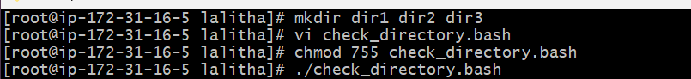

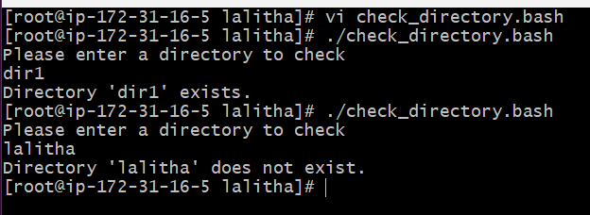
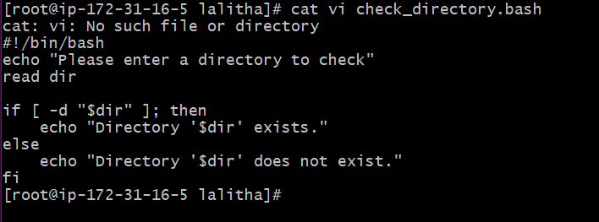
- Create a bash script to create multiple files.
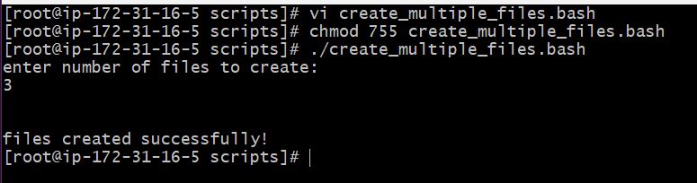

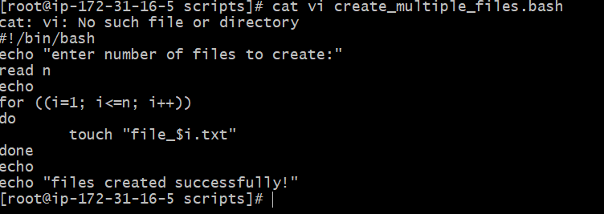
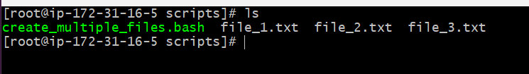
- Create a bash script to take a backup of a directory.
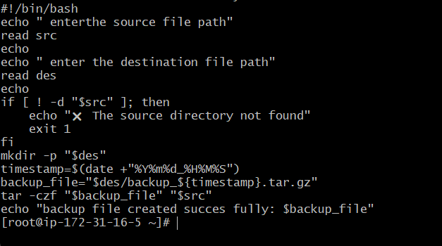
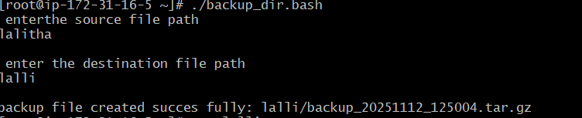

- Create a bash script to install Nginx on an EC2 server.

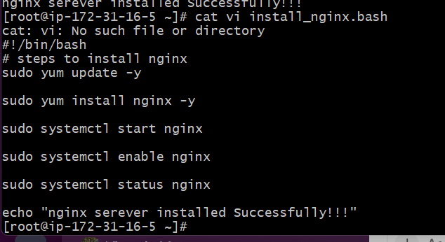

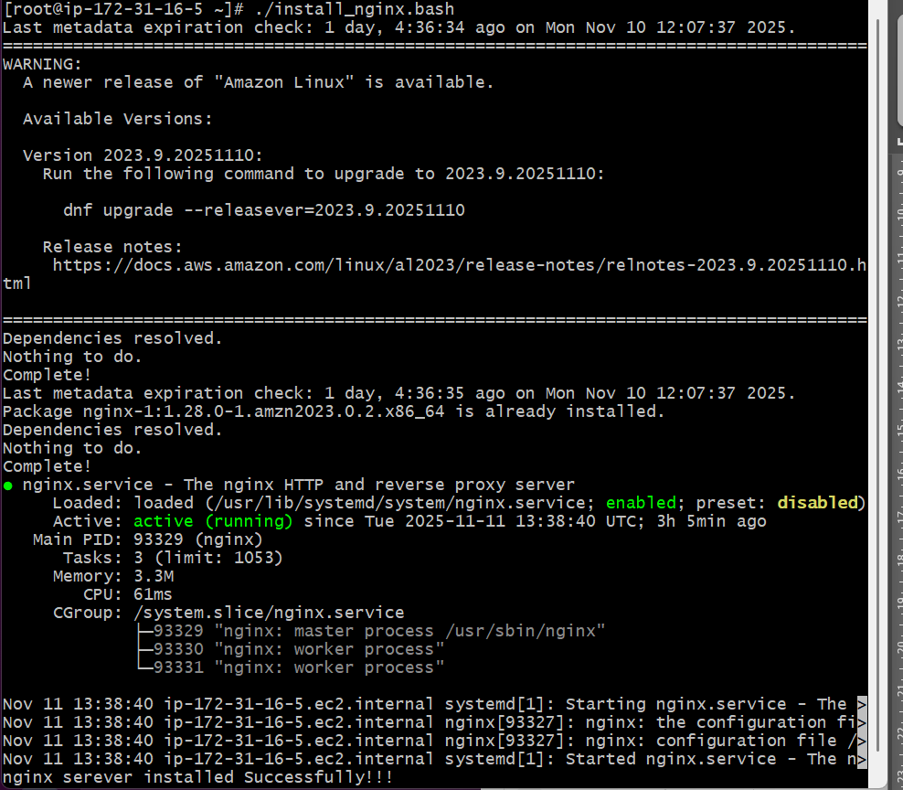
- . Create a bash script to install Apache Tomcat on an EC2 server.
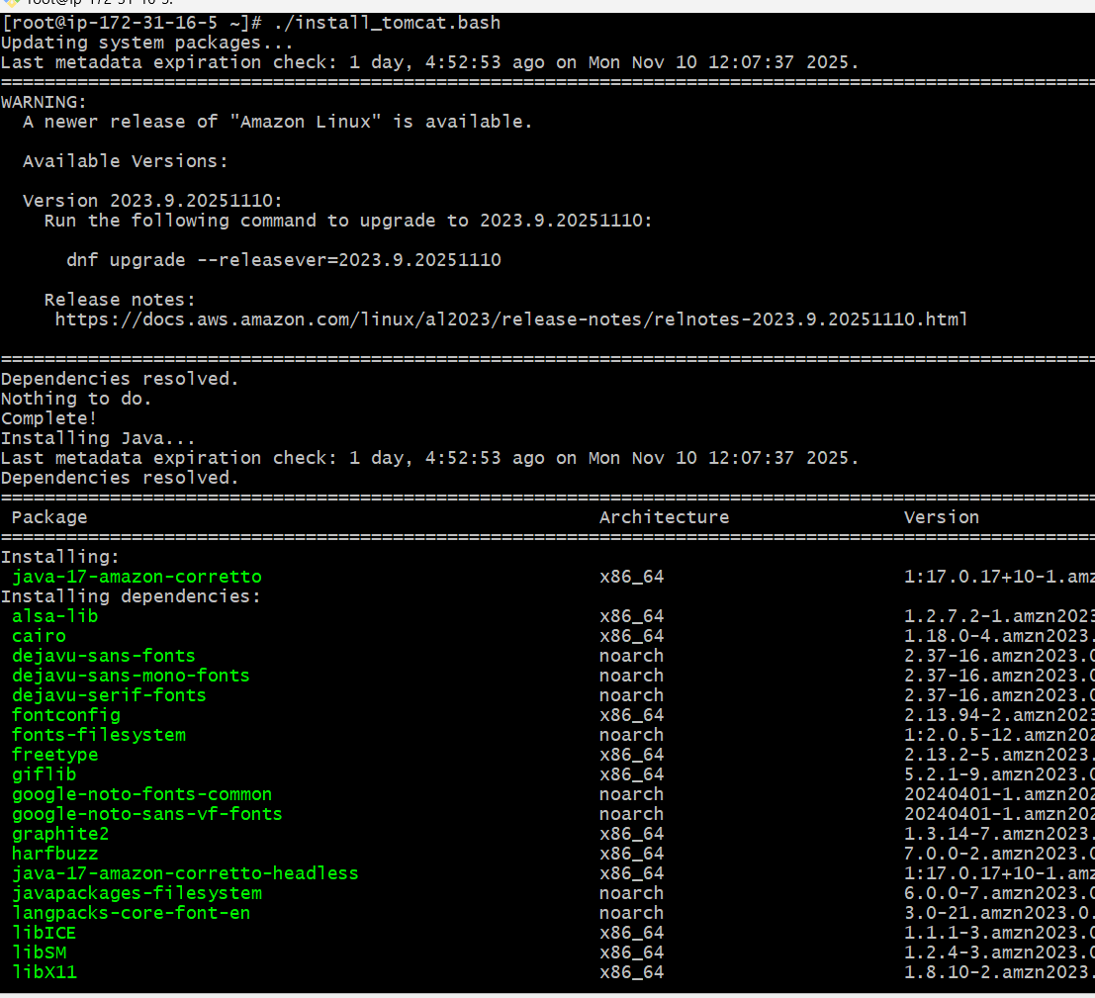
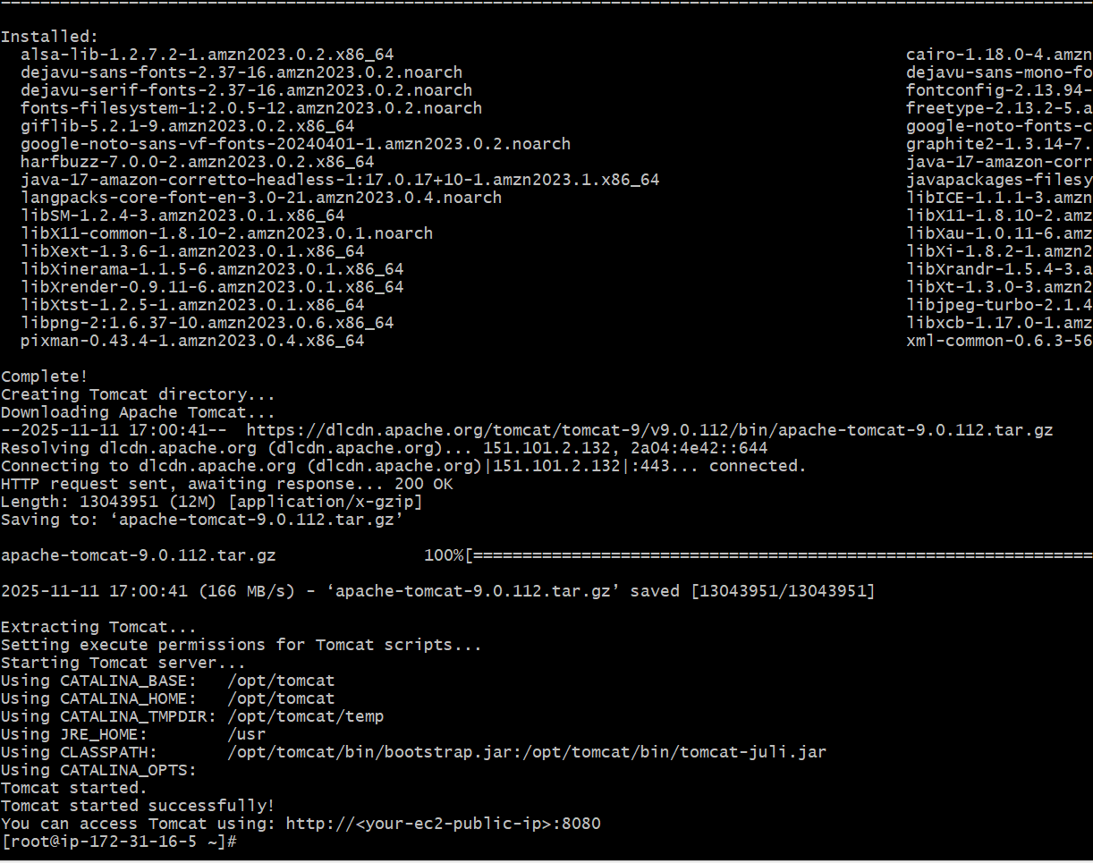
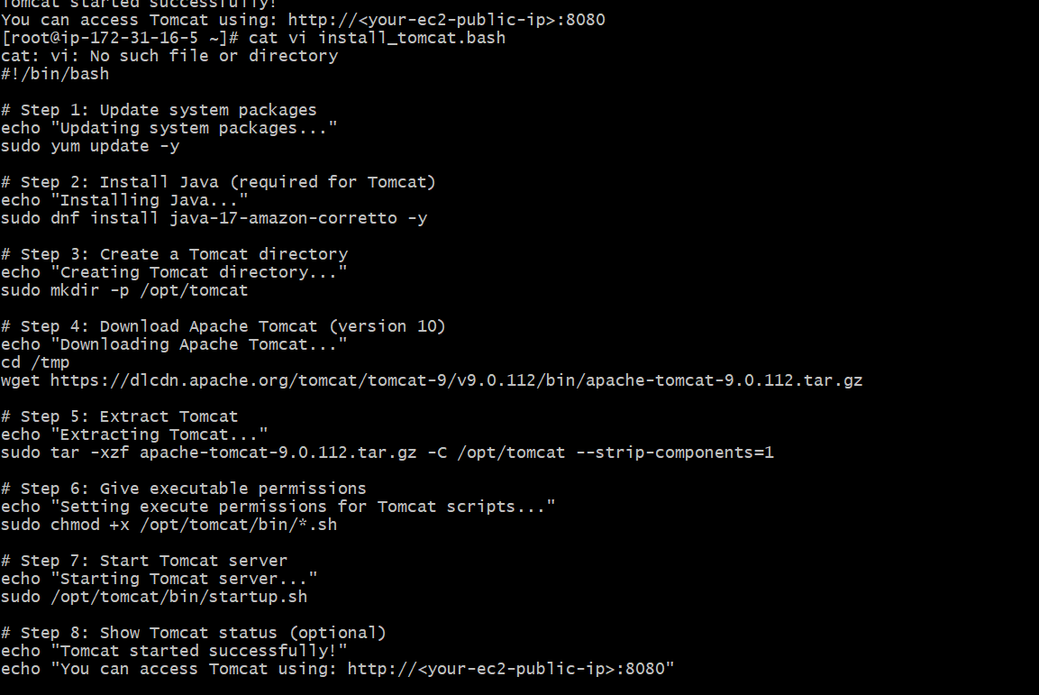
- Create a bash script to check if the Nginx service is running, if not running then script should start the service.
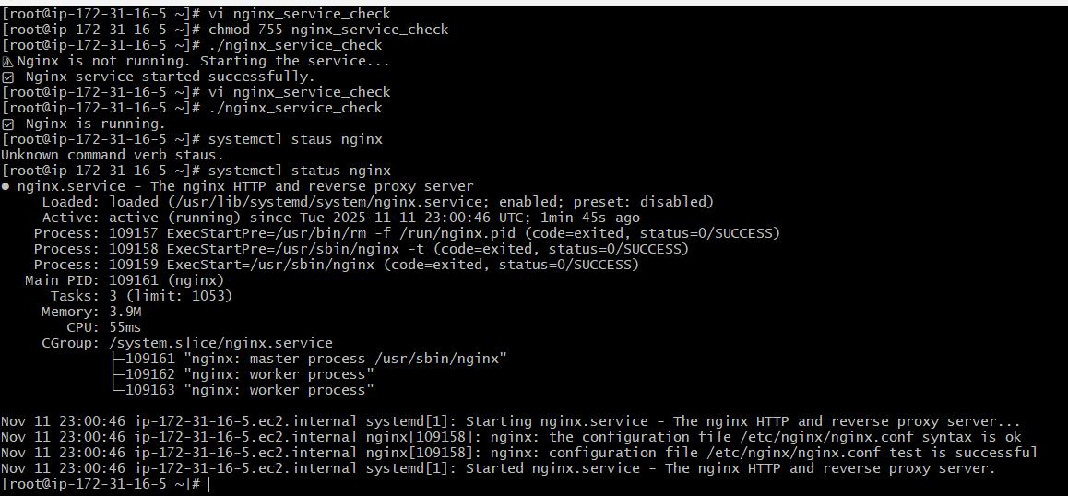
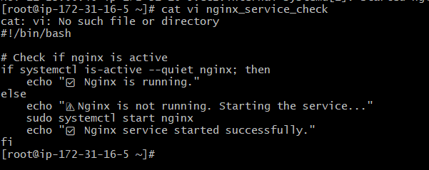
- Create a bash script for a calculator.
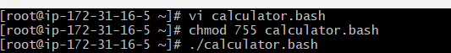
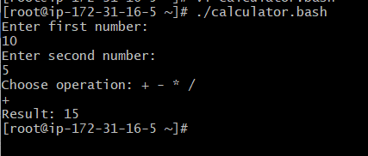
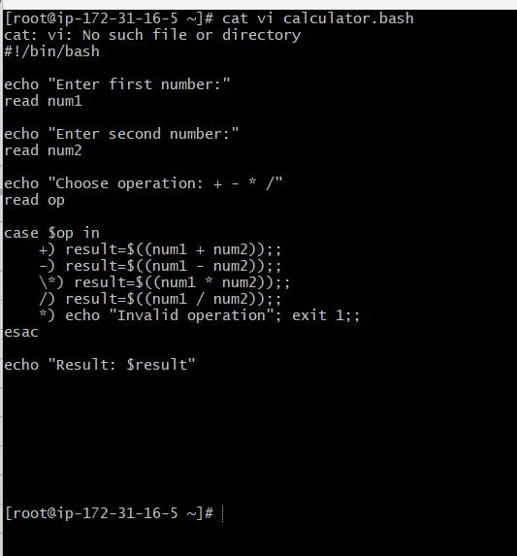

- Create a bash script to check if a directory exists, if not then create a directory.
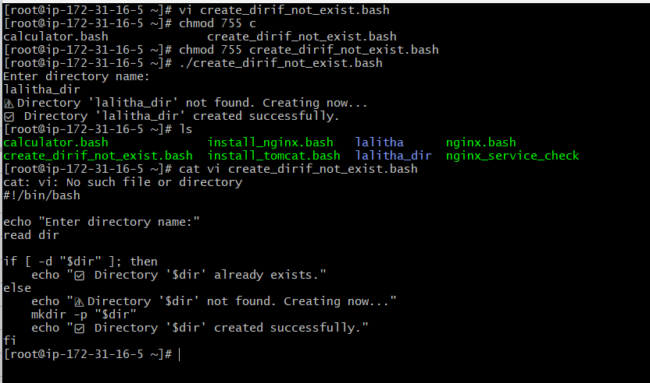

- Create a bash script to delete the last 3 lines of a file.
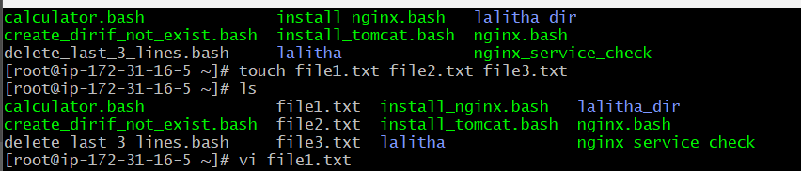
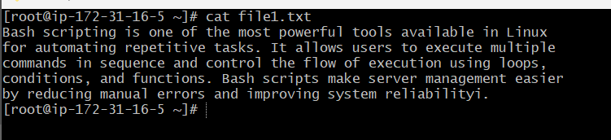
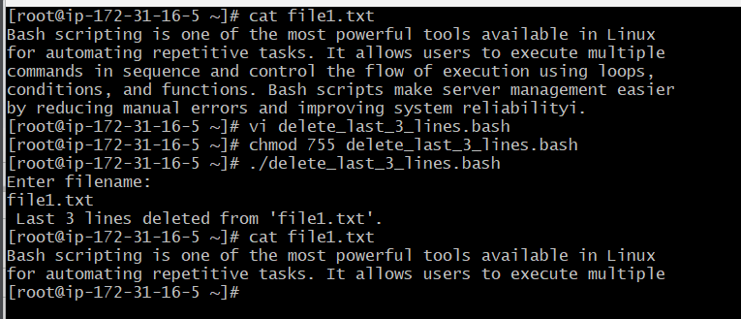

- Bash script to monitor cpu and if it is more than 80% then send email notification.
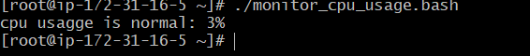
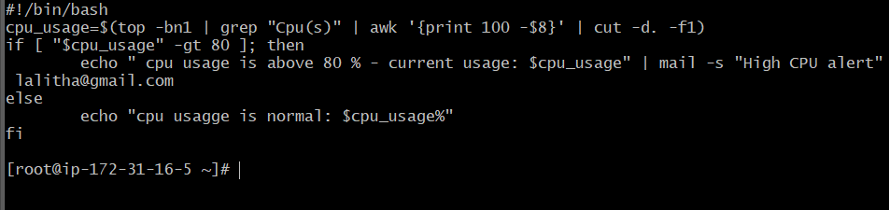
- ]Bash script to monitor disk space and if it is more than 80% then send email notification.
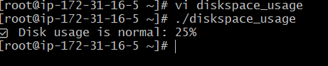
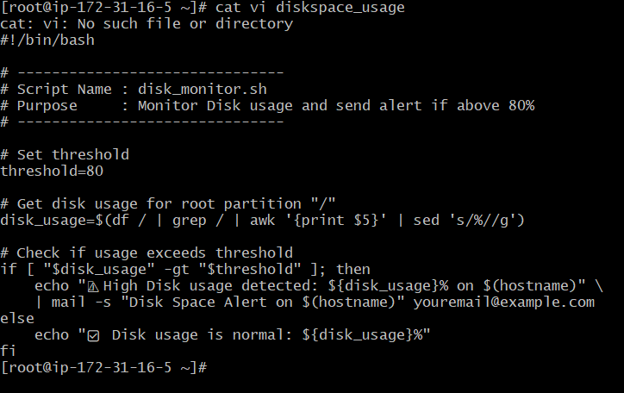
- Bash script to monitor memory and if it is more than 80% then send email notification. 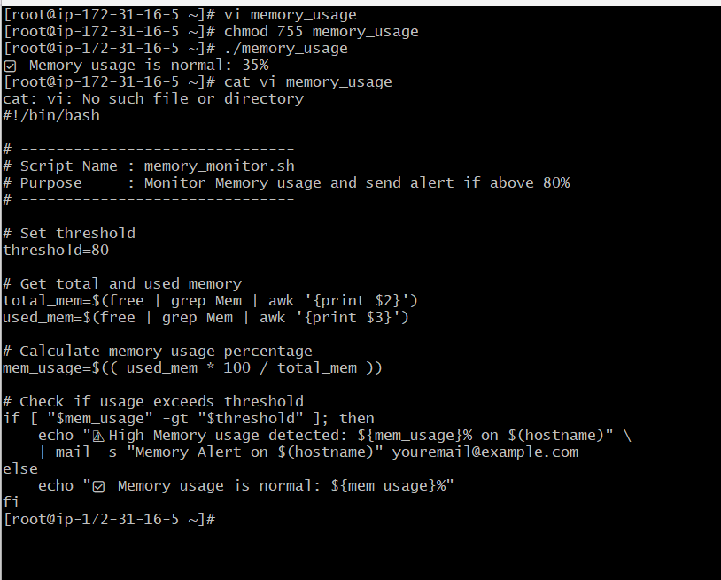
Exercise: Crontab Entries
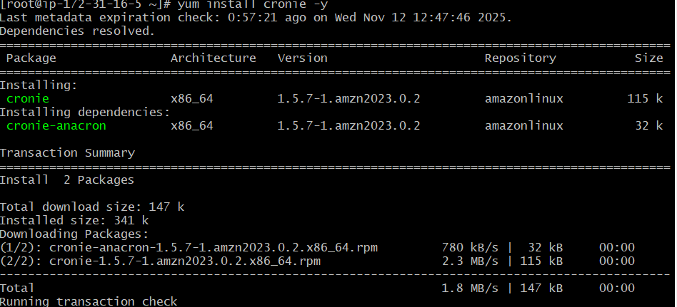
- April 5th Midnight
- 5th of Every November, January, June if it is a Thursday
- At 05 and 27th minutes of 9, 10, 11 hours every day
- 34 minutes of 9th hour on 15th August
- Every midnight
- Every Weekend (Saturday night 11:59 PM)
- After every reboot
